Foothills Piecemakers Philanthropy

Fat Quarter Fun Quilt Pattern
Finished Quilt Approximately 40” x 40”

Fabric Requirements:
1- Fat Quarter as your Focus Center Square, trimmed to 16.5” x 16.5” [shown below in white]. (Note: From the leftover fabric from cutting your large center square you should be able to get 2 rectangles that are 4.5” x 8.5” to use in the borders if you trim carefully.)

42 “scrappy” rectangles @ 4.5 x 8.5 – make the rectangles from fabrics scraps that coordinate with your center panel! If possible, use several different coordinating fabrics so you have at least 3-4 rectangles of each print. (Note: For a 40” x 48” quilt you will need 52 rectangles and you will also need 1 1/2 yards of backing.)

Backing - WOF x 48”” (approx. 1 1/3 yards of fabric)

Binding - 5 – 2 1/2” strips x WOF (approx. 1/2 yard of fabric)

Guild Label (for donation to Foothills Piecemakers Philanthropy)

Directions:
- On a design wall or flat surface, lay out your center square and arrange the rectangles as show in the illustration below, beginning with two rectangles at the top and two at the bottom. Next, arranging 3 rectangles down either side. Continuing this process across the top and bottom of the quilt until you have 3 rows on each side, as shown in the illustration below. Check to see that the rectangle prints are well distributed around the quilt center.
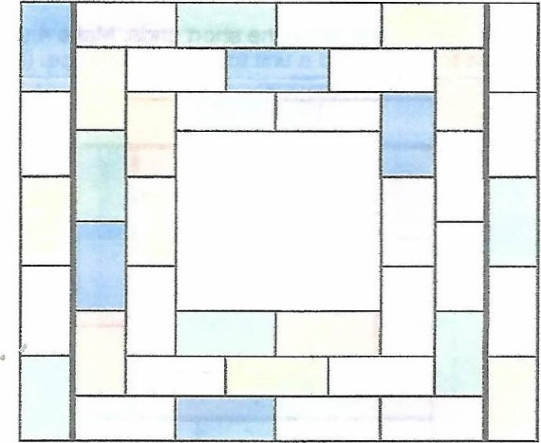

- Take the 2 rectangles at the top of the center square and sew them together on the short ends. Repeat with the 2 rectangles at the bottom of the center square. Press seams toward the right. Sew a unit to the top and bottom edges of the Focus Center Square as shown below. (Heavy lines represent seams.)

- Take the 3 Rectangles from each side and sew the them together on the short ends. Press side units “down” toward the bottom of the quilt. Sew a unit to each side of the center. Repeat with the top and bottom 3 rectangles, sewing the short ends together and pressing seams to the right. Sew a unit to the top edge and a unit to the bottom edge. (Heavy lines represent seams.)
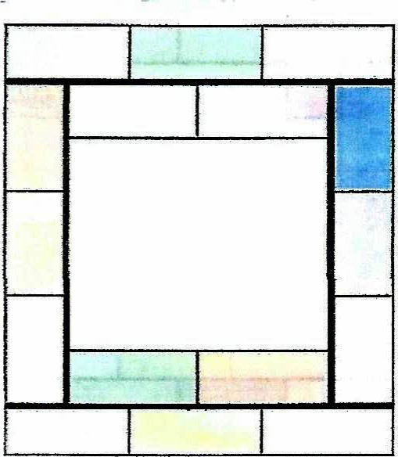

- Take 4 Rectangles and sew them together on the short ends. Make 4 sets of 4 rectangles. On two units, press the seams “down” toward the bottom of the quilt. Sew a unit to each side. On the remaining two units, press the seams to the right. Sew a unit to the top edge and a unit to the bottom edge. (Heavy lines represent seams.)
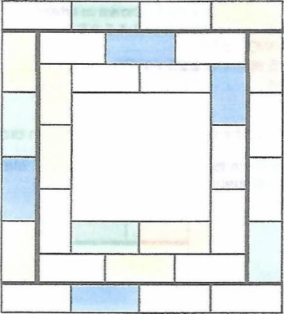

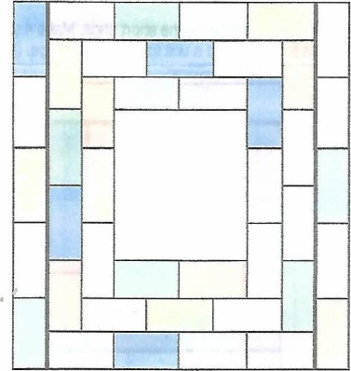
- Take 5 Rectangles and sew them together on the short ends. Make 2 units of 5 rectangles, pressing seams “down” toward the bottom of the quilt. Sew a unit to each side. (Heavy lines represent seams.)

- Quilting: Machine quilt with your choice of design. It can be a meander, stipple, diagonal lines, or design of your choice

- Binding: Join the 2 1/2” inch strips together with diagonal seams. Press seams open. Fold in half and press. Sew the binding to the quilt top either by hand or by machine using the stitch of your choice. Attach the FPQG label to the back lower right corner of the quilt.

- Note: This quilt pattern can easily be enlarged by adding more rows to the quilt. By adding just 1 more row to the top and bottom of the quilt you would need 10 more rectangles, 5 for the top and 5 for the bottom, and your new top would measure approximately 40” x 48”.

